**Installation**

To install Terraform, go to <https://www.terraform.io/downloads.html> and find the appropriate package for your operating system and download it as a zip archive.

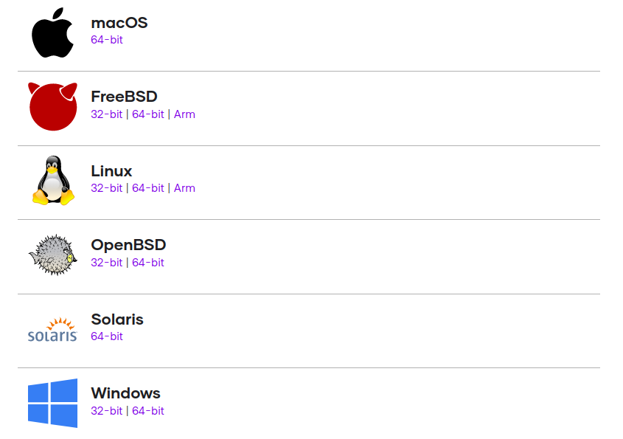

After downloading Terraform, unzip the package. Terraform runs as a single binary named terraform. Any other files in the package can be safely removed and Terraform will still function. (You can also compile the Terraform binary from source.)

Finally, make sure that the terraform binary is available on your PATH. This process will differ depending on your operating system. But we will explain the installation steps from downloading.

**For the Linux and Mac Users**

You can follow same steps for both MacOS and Linux operating systems. We will use Linux O.S but you can follow the same instructions except for the appropriate package link. Now copy the link address to download zip file.

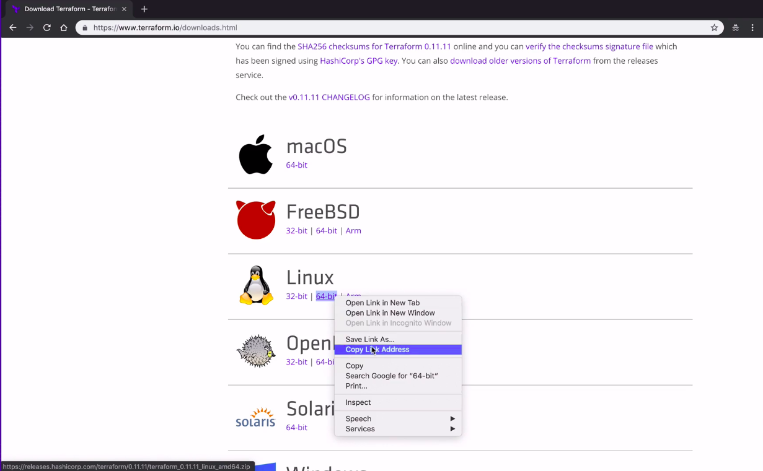

**Copy the link address for MacOS or Linux**

Then download and unzip the downloaded file with the following commands:

$ wget https://releases.hashicorp.com/terraform/0.12.26/terraform_0.12

    .26_linux_amd64.zip

$ unzip terraform_0.12.26_linux_amd64.zip

Then you can make directory for terraform and move terraform binary to this directory.

$ mkdir terraform_binary

$ mv terraform terraform_binary/

Now we will update our path so that we can call that binary anywhere on the machine. To set our pat on a MacOS machine or Linux machine we will edit our bash profile. To do that we should open .profile file with any text editor (such as vim or nano) and add following command to end of the file. Then save and exit.

export PATH="$PATH:~/terraform_binary"

**Note:**

* Be careful changing PATH variable is risky process so ensure that you are doing same with us.
* .profile is a hidden file so you may not see from home directory to see this file you can type `ls -la`
* This process will not automatically update current sessions `PATH` variable. To do this you can run **source ~/.profile** command in the command line.

To test the installation, type the following command:

$ terraform --version

**For the Windows Users**

If you are on Windows machine, the process is little different but we will do the same thing. We will download the correct binary file, unzip it, and set the path for the binary.

For the first step download windows binary from the given source to the top.

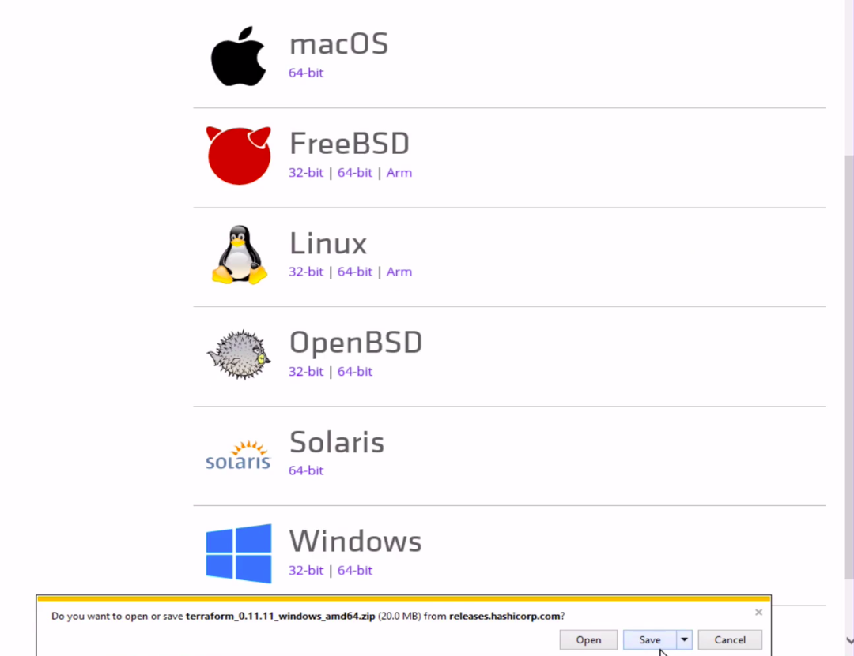

**Download for Windows**

After downloading the correct binary for your system from terraform.io, unzip it into any desired folder. We placed the binary in a new folder under C:\terraform

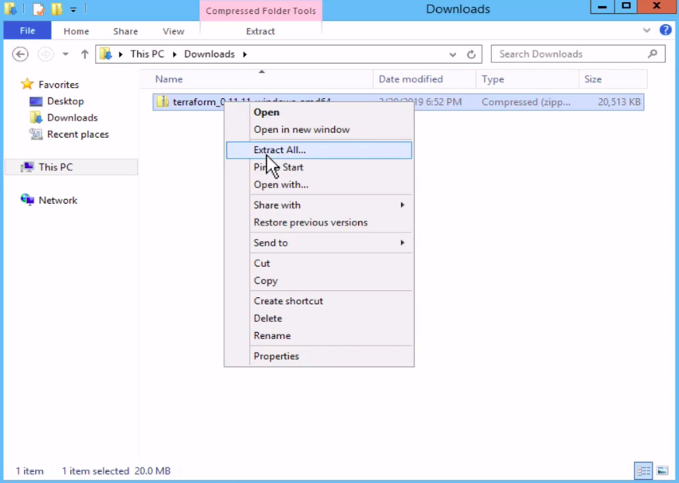

**Click extract all**

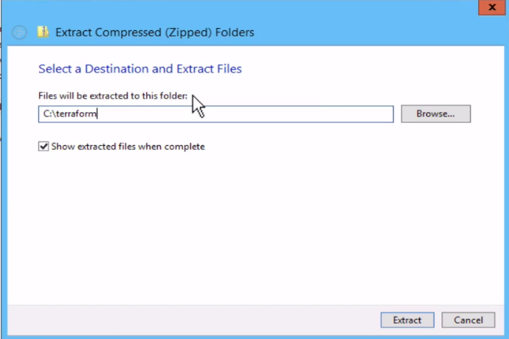

**Then you can specify where to extract**

To add the terraform binary path on your Windows go to Advanced System Settings.

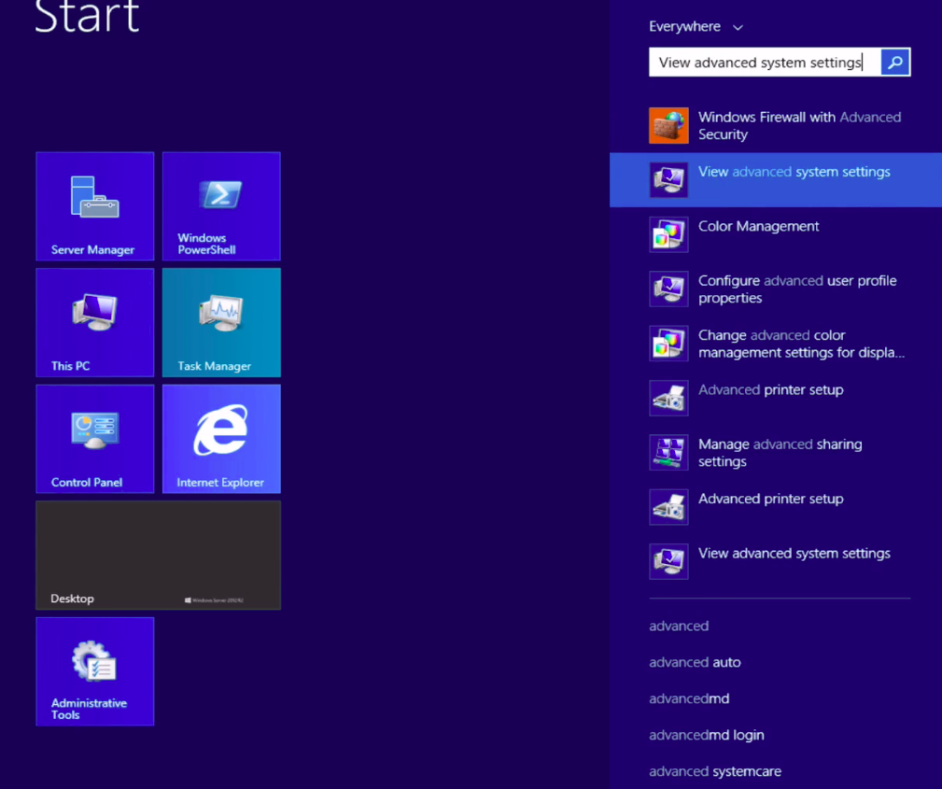

|  |
| --- |
| **Advanced System Settings** |

Then click environment variables:

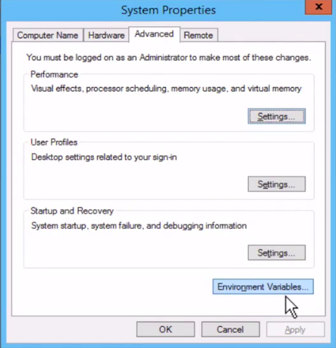

**Click environment variables**

Find the Path environment variable and select it and click to Edit.

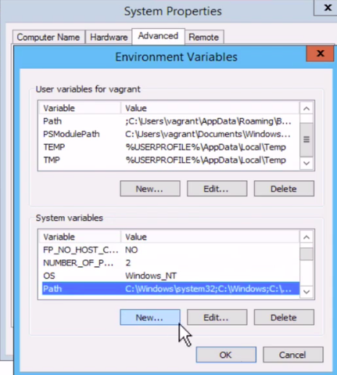

|  |
| --- |
| **Find the path and Edit** |

In the system variable window, type in the new path for your terraform download. In this example we moved binary file to C:\terraform\

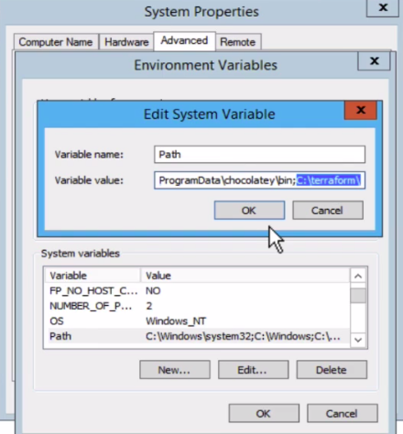

**Add the terraform path**

Then click OK and Apply. At the end go to your command line (you can open with PowerShell) and type terraform --version

$ terraform --version

### For Amazon Linux 2

Connect Amazon EC2 and type the following commands.

$ sudo yum update -y

$ sudo yum install -y yum-utils

$ sudo yum-config-manager --add-repo https://rpm.releases.hashicorp.com

    /AmazonLinux/hashicorp.repo

$ sudo yum -y install terraform

$ terraform --version

If you can see the version of Terraform...

🕺💃💥🔥🌪️ **CONGRATS** 🌪️ 🔥💥💃🕺

### Verify the Installation

You should already verify the installation with terraform --version command. If you want to see available commands with terraform you can use:

$ terraform -help

Add any subcommand to terraform -help to learn more about what it does and available options.

$ terraform -help plan

*Troubleshoot* *If you get an error that terraform could not be found, your PATH environment variable was not set up properly. Please go back and ensure that your PATH variable contains the directory where Terraform was installed.*

**Enable tab completion**

If you use either bash or zsh you can enable tab completion for Terraform commands. To enable autocomplete, run the following command and then restart your shell.

$ terraform -install-autocomplete

Formun Üstü

Complementary Lesson about Installation and Quick Start;

<https://youtu.be/h970ZBgKINg>